Program 3(a) and (b)

**NAME:** Anuj Solanki

**REGISTERED NO:** 20218411

**SUBJECT:** Dot Net LAB

**Aim:**

1. a. Validating Controls  
2. b. Numbers  
3. c. Texts  
4. d. Regular Expression

**Tools:** Visual Studio(.Net Framework) , MS Word.

**CODE:**

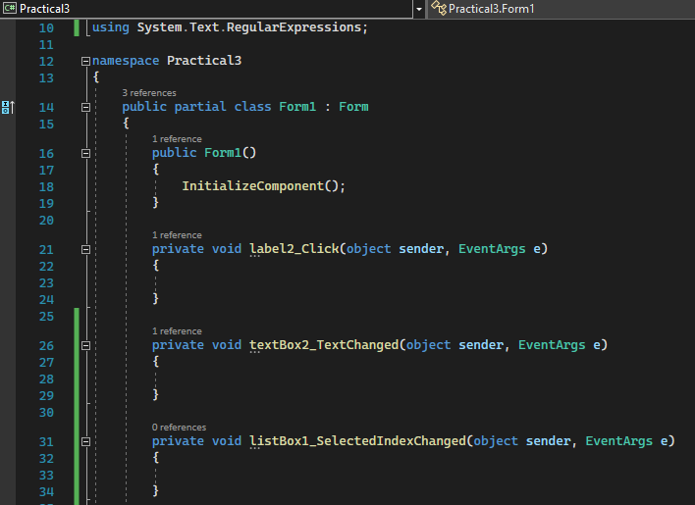

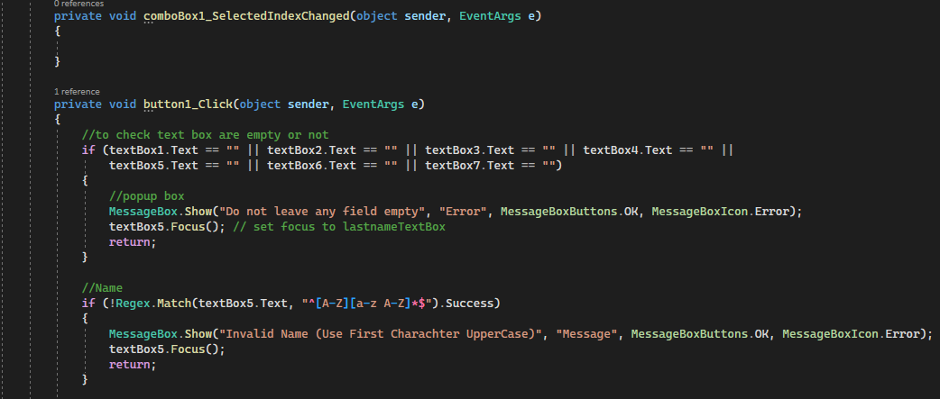

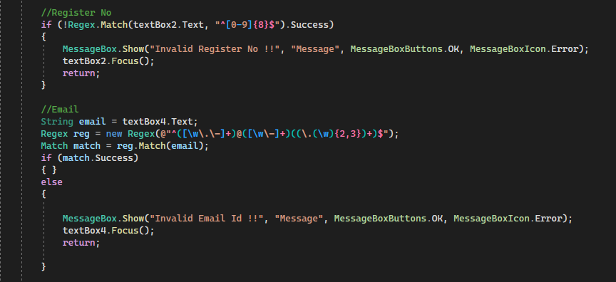

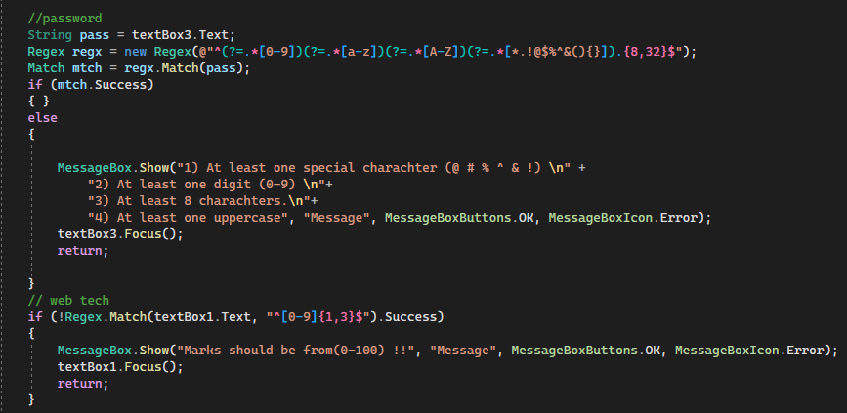

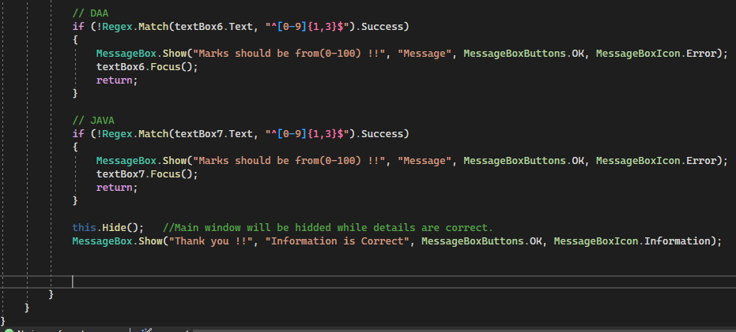

**OUTPUT:**

